PRESS RELEASE

FOR IMMEDIATE RELEASE

Pertamina Adds Fuel Supply to Labuan Bajo Ahead of ASEAN Summit

Kupang, Kominfo Newsroom – Pertamina Patra Niaga of East Java, Bali, Nusa Tenggara (Jatimbalinus) ensured that there would be an additional supply of fuel oil (BBM) to support the 2023 ASEAN Summit from 9 to 11 May 2023.

"Currently, Labuan Bajo is supported by the BBM Reo terminal, which is 120 kilometers from Labuan Bajo, and the total capacity of the terminal is 1,000 kiloliters," said Acting Area Manager Communication and CSR of Pertamina Patra Niaga Jatimbalinus, Taufik Kurniawan, when contacted, Thursday (20/4/2023 ).

Taufik explained that of this capacity, the daily consumption in Labuan Bajo is 54 kiloliters for gasoline and forty kiloliters for diesel-engined vehicles.

Therefore, his party estimated that during the 2023 ASEAN Summit, fuel consumption is expected to increase by up to thirty percent of the daily consumption of gasoline and diesel vehicle fuel.

"So we have ensured stock security at forty percent above the estimated consumption," he said.

He explained that so far, the distribution of fuel in Labuan Bajo has been supported by five gas stations in Labuan Bajo, which will be ready to serve the ASEAN Summit participants and the people in Labuan Bajo on a daily basis.

Pertamina Patra Niaga Jatimbalinus has also established a Komodo Aircraft Refueling Depot (DPPU) attached to the Komodo airport for aircraft refueling stations.

"The DPPU serves 27.4 kiloliters of avtur fuel per day," he said.

In addition to the increase in other sectors, he added that it is estimated that there will also be an increase in avtur consumption, like the increase in other public transportation.

Furthermore, he said the DPPU Komodo already has personnel certified to refuel international and presidential aircraft.

"So basically, we are ready to serve the guests of the 2023 ASEAN Summit who will visit Labuan Bajo," he said.

Indonesia's chairmanship in ASEAN started on 1 January 2023 and will last a year until 31 December 2023. The 2023 ASEAN Summit will be held twice in two places, namely in Labuan Bajo from 9 to 11 May 2023 and Jakarta in September 2023.

Many parties have high expectations for Indonesia that it can make breakthroughs and innovations in dealing with various world problems the region faces.

Through the theme of ASEAN Chairmanship, namely: "ASEAN Matters: Epicentrum of Growth", Indonesia is determined to direct ASEAN cooperation in 2023 to continue and strengthen ASEAN's relevance in responding to regional and global challenges as well as enhance ASEAN's position as the center of regional economic growth, for the prosperity of the ASEAN people. (Kornelis/ TR/Elvira)

***

For further information, please contact:
Director General of Public Information and Communications of the Ministry of Communications and Informatics – Usman Kansong (0816785320).

Get more information at https://infopublik.id

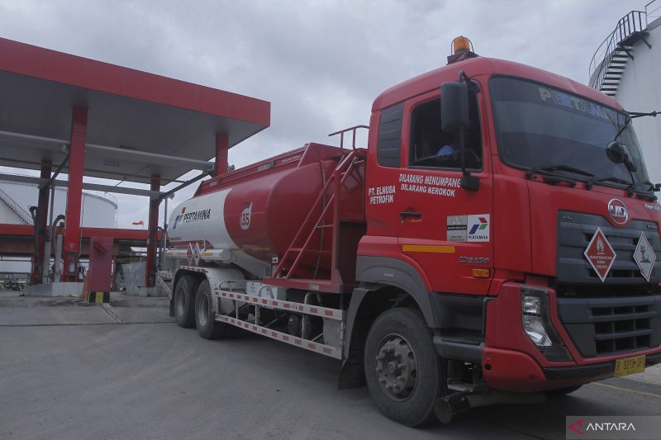

Archive. One unit of Pertamina fuel truck is leaving the Tenau Gas Station in Kupang.

Photo: ANTARA/Kornelis Kaha

